Chapter 9, Problem 1
(a) How is raw pig iron extracted from iron oxide ores? (b) Write a typical chemical reaction for the reduction of iron oxide (Fe₂O₃) by carbon monoxide to produce iron. (c) Describe the basic oxygen process for converting pig iron into steel.

Chapter 9, Solution 1
(a) Raw pig iron is typically extracted from iron oxide ores in a blast furnace in which coke (carbon) acts as a reducing agent of the iron oxides. The pig iron produced contains approximately 4 percent carbon. (b) The typical chemical reaction is: 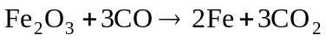. (c) In the basic-oxygen process, pig iron is converted into steel through oxidation in a refractory-lined converter. An oxygen lance insert provides pure oxygen to the bath of molten pig iron and scrap steel. The iron oxide formed then reacts with the carbon in the steel to form carbon monoxide: 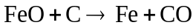

Chapter 9, Problem 2
(a) Why is the Fe-Fe₃C phase diagram a metastable phase diagram instead of a true equilibrium phase diagram? (b) Define the following phases that exist in the Fe-Fe₃C phase diagram: (i) austenite, (ii) α ferrite, (iii) cementite, (iv) δ ferrite. (c) Write the reactions for the three invariant reactions that take place in the Fe-Fe₃C phase diagram.

Chapter 9, Solution 2
(a) The 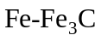phase diagram is a metastable phase diagram rather than a true equilibrium phase diagram because the compound iron carbide (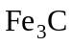) formed, cementite, is not a true equilibrium phase. While cementite is typically very stable, it can decompose into iron and carbon under certain conditions.

(b)
- Austenite, the interstitial solid solution of carbon in γ iron, has an FCC crystal structure and a relatively high maximum solid solubility of carbon (2.08 percent).
- An interstitial solid solution of carbon in the BCC iron crystal lattice, α ferrite has a maximum solid solubility of carbon of 0.02 percent.
- Cementite, , is a hard, brittle intermetallic compound with a carbon content of 6.67 percent.
- An interstitial solid solution in δ iron, δ ferrite has a BCC crystal structure and a maximum solid solubility of carbon of 0.09 percent.

(c) The three invariant reactions that take place in the phase diagram are a peritectic reaction, a eutectic reaction, and a eutectoid reaction.

Peritectic:

Eutectic:

Eutectoid:

Chapter 9, Problem 3
(a) What is the structure of pearlite? (b) Draw a schematic showing all the appropriate phases.

Chapter 9, Solution 3
(a) Pearlite has a lamellar (plate-like) structure consisting of alternating plates of α ferrite and cementite (). (b)Refer to Figure 9.8 (the structure and its micro-constituents are presented).

Chapter 9, Problem 4
Distinguish between the following three types of plain-carbon steels: (a) eutectoid, (b) hypoeutectoid, and (c) hypereutectoid.

Chapter 9, Solution 4
- Eutectoid plain-carbon steel contains 0.8 percent carbon.
- Hypoeutectoid plain-carbon steel contains less than 0.8 percent carbon.
- Hypereutectoid plain-carbon steel contains more than 0.8 percent carbon.

Chapter 9, Problem 5
Distinguish between proeutectoid ferrite and eutectoid ferrite.

Chapter 9, Solution 5
Proeutectoid ferrite is the ferrite formed during cooling from the upper transformation temperature to just above the eutectoid temperature, where as, eutectoid ferrite is produced during the eutectoid reaction at the eutectoid temperature of 723°C.

Chapter 9, Problem 6
(a) Define an Fe-C martensite. (b) Describe the following types of Fe-C martensites that occur in plain-carbon steels: (i) lath martensite, (ii) plate martensite. (c) Describe some of the characteristics of the Fe-C martensite transformation that occurs in plain-carbon steels. (d) What causes the tetragonality to develop in the BCC iron lattice when the carbon content of Fe-C martensites exceeds about 0.2 percent? (e) What causes the high hardness and strength to be developed in Fe-C martensites of plain-carbon steels when their carbon content is high?

Chapter 9, Solution 6
(a) An 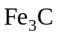 martensite is a plain-carbon steel whose structure is formed by rapid cooling of the austenitic condition and consists of a supersaturated interstitial solid solution of carbon in body-centered cubic iron or body-centered tetragonal iron. This transformed state is a metastable phase.
(b)
- Lath martensite occurs in plain-carbon steels containing less than approximately 0.6 percent carbon. Its structure consists of domains of laths which are highly distorted and contain regions with high densities of dislocation tangles.
- Plate martensite forms in plain-carbon steels having more than 0.6 percent carbon. For martensites with 0.6 to 1.0 percent C, the microstructure consists of both lath- and plate-type martensite while steels containing more than 1.0 percent C consist entirely of plates which vary in size, have a fine structure of parallel twins, and are often surrounded by untransformed austenite.

(c)
- The transformation is considered to be diffusionless because the transformation occurs so rapidly.
- There is no apparent thermal-activation barrier to prevent martensite from forming.
- The relative positions of the carbon atoms, with respect to the iron atoms, in the martensite are the same as in the austenite.
- In Fe-C martensites with less than about 0.2% C, the austenite transforms into a BCC α ferrite crystal structure. Whereas martensites containing more than about 0.2% C develop a tetragonality in the BCC structure leading to a BCT structure.

(d) When the carbon content of 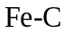 martensites exceeds about 0.2 percent, tetragonality develops as a result of the carbon atoms distorting the BCC unit cell along its c axis; the 0.154 nm diameter carbon atoms are large relative to the largest interstitial hole in the α iron BCC lattice which measures approximately 0.072 nm in diameter. By comparison, the FCC γ iron unit cell has interstitial holes measuring up to 0.104 nm in diameter. (e) The high hardness and strength of Fe-C martensites of high carbon content is attributed to two effects: the increased extent of interstitial solid-solution of carbon atoms in the BCC iron lattice; and the numerous twinned interfaces which act as barriers to dislocations in plate martensite

Chapter 9, Problem 7
(a) What is an isothermal transformation in the solid state? (b) Draw an isothermal transformation diagram for a plain-carbon eutectoid steel and indicate the various decomposition products on it. How can such a diagram be constructed by a series of experiments?

Chapter 9, Solution 7
(a) An isothermal transformation is one which takes place at constant temperature. For solid state eutectoid plain-carbon steels, isothermal transformation is achieved by quenching austenitic samples at 723°C or higher in a salt bath maintained at a specific temperature below the 723°C eutectoid point.
(b)
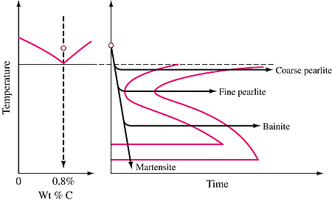

This isothermal transformation diagram for a plain-carbon steel can be constructed experimentally by using a small number of dime-size samples. The samples are first austenitized in a furnace, at a temperature above 723°C, and then rapidly cooled in a liquid salt bath at the desired transformation temperature, below 723°C. Individual samples are subsequently removed at specific transformation time intervals and quenched in room temperature water. The microstructure associated with each transformation time is then examined. Finally, the entire process is repeated for various transformation temperatures and the results plotted on the IT diagram.

Chapter 9, Problem 8
How does the isothermal transformation diagram for a hypoeutectoid plaincarbon steel differ from that of a eutectoid one?

Chapter 9, Solution 8
The two primary differences are:

- the S curves of the hypoeutectoid steel are shifted to the left, rendering impossible the quenching from the austenitic region to produce a purely martensitic structure;
- an additional transformation line exists in the upper part of the eutectoid steel IT diagram, indicating the start of the formation of proeutectoid ferrite.

Chapter 9, Problem 9
Draw a continuous-cooling transformation diagram for a eutectoid plain-carbon steel. How does it differ from a eutectoid isothermal transformation diagram for a plain-carbon steel?

Chapter 9, Solution 9

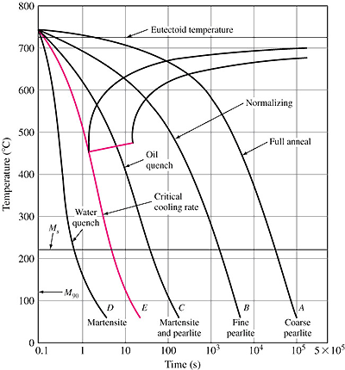

As depicted in Fig. 9.27 above, the continuous-cooling transformation diagram for a eutectoid plain-carbon steel possesses longer time intervals between the start and finish times and lower transformation temperatures relative to the isothermal diagram. Also, there are no transformation lines below about 450°C for austenite-to-pearlite transformations.

Chapter 9, Problem 10
Describe the full-annealing heat treatment for a plain-carbon steel. What types of microstructures are produced by full annealing (a) a eutectoid steel and (b) a hypoeutectoid steel?

Chapter 9, Solution 10
For a plain-carbon steel, the full-annealing heat treatment process consists of: heating the steel within the austenite region, approximately 40°C above the austenite-ferrite boundary; maintaining the elevated temperature for a sufficient time; and then slowly cooling the steel to room temperature. Hypereutectoid steels are typically austenitized in the two-phase austenite plus cementite region, about 40°C above the eutectoid temperature.

- Full annealing of a eutectoid steel results in a pearlite structure.
- Full annealing of hypoeutectoid steels produces a microstructure consisting of both pearlite and proeutectoid ferrite.

Chapter 9, Problem 11
Describe the process-annealing heat treatment for a plain-carbon hypoeutectoid steel with less than 0.3 percent C.

Chapter 9, Solution 11
Plain-carbon hypoeutectoid steels with less than 0.3 percent C are usually process annealed, or stress relieved, by heating to a temperature below the eutectoid temperature, usually between 550 and 650°C.

Chapter 9, Problem 12
What is the normalizing heat treatment for steel and what are some of its purposes?

Chapter 9, Solution 12
The normalizing heat treatment for steel consists of heating within the austenitic region and then cooling in still air. Some of the purposes for normalizing include:

- to refine the grain structure;
- to increase the strength of the steel, as compared to annealed steel;
- to reduce compositional segregation in castings or forgings and thus provide a more uniform structure.

Chapter 9, Problem 13
Describe the tempering process for a plain-carbon steel.

Chapter 9, Solution 13
Tempering of a plain-carbon steel is accomplished by first austenitizing and then quenching the steel at a rapid rate to produce a completely martensitic structure. Subsequently, the steel is reheated to a temperature below the eutectoid temperature in order to soften the martensite; the martensite is transformed to a structure of iron carbide particles in a matrix of ferrite.

Chapter 9, Problem 14
Describe the martempering (marquenching) process for a plain-carbon steel. (b) Draw a cooling curve for a martempered (marquenched) austenitized eutectoid plain-carbon steel by using an IT diagram. (c) What type of microstructure is produced after martempering this steel? (d) What are the advantages of martempering? (e) What type of microstructure is produced after tempering a martempered steel? (f) Why is the term martempering a misnomer? Suggest an improved term.

Chapter 9, Solution 14
(a) The martempering or marquenching process for a plain-carbon steel produces a martensitic microstructure and consists of:
- austenitizing the steel;
- quenching the steel in oil or molten salt at a temperature just slightly above the 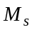 temperature;
- holding the steel in the quenching medium temperature for a time period sufficient to provide thermal equilibrium of the steel with the medium, without causing the initiation of the austenite-to-bainite transformation;
- cooling the steel at a moderate rate to room temperature.

(b) A schematic of the cooling curve for a martempered eutectoid plain-carbon steel is shown in the IT diagram below.

(d) The advantages of martempering are the minimization of distortion and cracking of the workpiece. (e) By subsequent tempering, the martempered steel develops a tempered martensite microstructure which provides for higher impact energy.

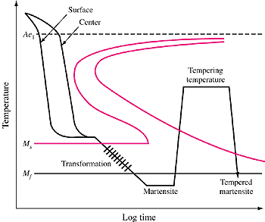

(f) Martempering is a misnomer because the steel is quenched rather than tempered; thus, a more accurate term is marquenching.

Chapter 9, Problem 15
(a) Describe the austempering process for a plain-carbon steel. Draw a cooling curve for an austempered austenitized eutectoid plain-carbon steel by using an IT diagram. (b) What is the microstructure produced after austempering a eutectoid plaincarbon steel? (c) Does an austempered steel need to be tempered? Explain. (d) What are the advantages of the austempering process? (e) Disadvantages?

Chapter 9, Solution 15
(a) In the austempering process, the steel is austenitized, then quenched in a molten salt bath at a temperature just above the steel M_{s} temperature, held isothermally until the austenite-to-bainite transformation is complete, then cooled to room temperature in air. The cooling curve for the austempering of eutectoid plain-carbon steel is shown in Fig. P9.34.
(b) After austempering, a eutectoid plain-carbon steel has a bainite microstructure.
(c) Subsequent tempering is not necessary since the austempering results in hardness, distortion and impact energy values comparable to or better than those associated with a marquenched and tempered steel.

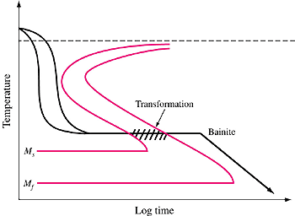

P9.34 Cooling curve for martempering superimposed
on a eutectoid plain-carbon steel IT diagram.

(d) Advantages of austempering include: ductility and impact resistance values which exceed those of a quenched and tempered steel; decreased distortion compared to a quenched steel.
(e) The disadvantages are the need for a special molten salt bath and limited applicability to specific steels.

Chapter 9, Problem 16
(a) Explain the numbering system used by the AISI and SAE for plain-carbon steels. (b) What is the AISI-SAE system for designating low-alloy steels?

Chapter 9, Solution 16
(a) Plain-carbon steels are designated by the AISI-SAE code using four digits. The first two digits, 10, indicate that the steel is a plain-carbon type. The last two digits indicate the nominal carbon content of the steel in hundredths of a percent. Thus a 1030 steel contains a nominal carbon content of 0.30 percent.
(b) For low-alloy steels, the AISI-SAE system uses four-digits to designate the alloy: the first two digits indicate the principal alloying element or group of elements in the steel; the second two digits indicate the carbon content in hundredths of a percent.

Chapter 9, Problem 17
(a) What are some of the limitations of plain-carbon steels for engineering designs? (b) What are the principal alloying elements added to plain-carbon steels to make low-alloy steels? (c) What elements dissolve primarily in the ferrite of carbon steels? (d) List in order of increasing carbide-forming tendency the following elements: titanium, chromium, molybdenum, vanadium, and tungsten.

Chapter 9, Solution 17
(a) Limitations of plain-carbon steels include:
- Plain-carbon steels cannot be strengthened beyond about 100,000 psi (690 MPa) without experiencing a substantial loss of ductility and impact resistance.
- Plain-carbon steels are not deep-hardenable; large-section thicknesses, having a martensitic structure throughout, cannot be produced.
- Plain-carbon steels have low corrosion and oxidation resistance.
- In order to achieve a fully martensitic structure, medium-carbon plain-carbon steels must be quenched rapidly and are thus susceptible to distortion and cracking.
- Plain-carbon steels have poor impact resistance at low temperatures.

(b) Low-alloy steels are formed by adding one or more of five principal alloying elements – manganese, molybdenum, chromium, nickel, and silicon – such that the carbon content is reduced by one to four percent.
(c) Nickel, silicon and manganese dissolve primarily in the α ferrite of carbon steels. (d) The carbide-forming tendency, in increasing order, is: chromium, molybdenum, tungsten, vanadium, and titanium.

Chapter 9, Problem 18
(a) What compounds does aluminum form in steels? (b) Name two austenite-stabilizing elements in steels. (c) Name four ferrite-stabilizing elements in steels.

Chapter 9, Solution 18
(a) Aluminum forms the compounds 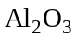 and 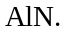 (b) Manganese and nickel are austenite-stabilizing elements for steel. (c) Tungsten, molybdenum, titanium and vanadium are ferrite-stabilizing elements in steels.

Chapter 9, Problem 19
Which elements raise the eutectoid temperature of the Fe-Fe₃C phase diagram? Which elements lower it?

Chapter 9, Solution 19
The carbide-forming, ferrite-stabilizing elements such as titanium, vanadium and tungsten raise the eutectoid temperature while the austenite-stabilizing elements such as nickel and manganese lower the eutectoid point.

Chapter 9, Problem 20
(a) Define the hardenability of a steel. (b) Define the hardness of a steel. (c) Describe the Jominy hardenability test. (d) Explain how the data for the plotting of the Jominy hardenability curve are obtained and how the curve is constructed. (e) Of what industrial use are Jominy hardenability curves?

Chapter 9, Solution 20
(a) The hardenability of a steel is a property which defines the depth and distribution of hardness induced by quenching at the austenitic condition. It is typically measured using the Jominy hardenability test.
(b) In contrast, the hardness of a steel is a measure of the metal’s resistance to plastic deformation, usually by indentation.
(c) In the Jominy hardenability test, a cylindrical bar, having a 1 in. diameter, a 4 in. length, and a 1/16 in. flange at one end, is used as a specimen. The specimen is austenitized, placed in a fixture and quickly cooled at one end by a water jet. Once the bar is cool, two parallel flat surfaces are ground on opposite sides of the test bar and Rockwell C hardness tests are performed along the flat surfaces.
(d) The data for the Jominy hardenability curve is obtained by taking a series of Rockwell C hardness measurements, starting at the quenched end and moving along the flat surfaces over a distance of 2.5 inches. The curve is then constructed by plotting hardness versus distance from the quenched end.
(e) Jominy hardenability curves serve as an effective material selection tool; the curves provide a means of quickly comparing the hardness values of various low-alloy steels.

Chapter 9, Problem 21
(a) Explain how a precipitation-hardenable alloy is strengthened by heat treatment. (b) What type of phase diagram is necessary for a binary alloy to be precipitation-hardenable? (c) What are the three basic heat-treatment steps to strengthen a precipitation-hardenable alloy? (d) In what temperature range must a binary precipitation-hardenable alloy be heated for the solution heat-treatment step? (e) Why is a precipitation-hardenable alloy relatively weak just after solution heat treatment and quenching?

Chapter 9, Solution 21
(a) Heat treatment strengthens a precipitation-hardenable alloy by causing the formation of a dense and fine dispersion of precipitated particles within a matrix of deformable metal. These particles provide strength by obstructing dislocation movement.
(b) The binary phase diagram must have a terminal solid solution for which the solid solubility decreases with decreasing temperature.
(c) The three basic heat-treatment steps are solution heat treatment, quenching, and aging.
(d) During solutionizing, a binary precipitation-hardenable alloy must be heated to a temperature between the solvus and solidus temperatures.
(e) After solution heat treatment and quenching, the precipitation-hardenable alloy is relatively weak because its microstructure consists of a supersaturated solid solution with no precipitates. The aging process allows this high-energy, unstable phase to decompose into metastable and equilibrium phases having lower energy and a matrix of finely dispersed precipitate.

Chapter 9, Problem 22
(a) Distinguish between natural aging and artificial aging for a precipitation-hardenable alloy. (b) What is the driving force for the decomposition of a supersaturated solid solution of a precipitation-hardenable alloy? (c) What is the first decomposition product of a precipitation-hardenable alloy in the supersaturated solid-solution condition after aging at a low temperature? (d) What are GP zones?

Chapter 9, Solution 22
(a) In natural aging, the alloy is aged at room temperature, whereas artificial aging is performed at elevated temperatures.
(b) The driving force for the decomposition of a supersaturated solid solution into metastable and equilibrium phases is the lowering of the system energy when these phases form.
(c) The first decomposition product is the formation of precipitation or GP zones.
(d) GP zones are clusters of segregated solute atoms within a solvent matrix.

Chapter 9, Problem 23
(a) What is an aging curve for a precipitation-hardenable alloy? (b) What types of precipitates are developed in an alloy that is considerably underaged at low temperatures? (c) What types are developed upon overaging?

Chapter 9, Solution 23
(a) An aging curve for a precipitation-hardenable alloy is a plot of strength or hardness versus aging time for a particular temperature.
(b)If an alloy is underaged at low temperatures, GP zones precipitate.
(c) Upon overaging, intermediate precipitates coalesce and coarsen, making the alloy weaker than an alloy aged to its peak condition.

Chapter 9, Problem 24
What is the difference between a coherent precipitate and an incoherent one?

Chapter 9, Solution 24
In a coherent precipitate, the solute atoms simply replace the solvent atoms of the matrix lattice; whereas in an incoherent precipitate, the precipitate particle has a distinct crystal structure.

Chapter 9, Problem 25
Describe the four decomposition structures that can be developed when a supersaturated solid solution of an Al–4% Cu alloy is aged.

Chapter 9, Solution 25
The four decomposition structures that can be developed are as follows.

  - GP1 zones consist of segregated regions in the shape of disks a few atoms thick (0.4 to 0.6 nm) and about 8 to 10 nm in diameter. They form on the {100} cubic planes, straining the lattice tetragonally, and are coherent with the matrix.
  - GP2 zones are approximately 1 to 4 nm thick and 10 to 100 nm in diameter. These zones are also coherent with the {100} matrix and have a tetragonal structure.
  - The θ’ phase nucleates heterogeneously and is incoherent with the matrix. This phase has a tetragonal structure with a thickness of 10 to 150 nm.
  - The θ phase is an incoherent equilibrium phase having the composition CuAl₂. This phase, which forms from θ’ or directly from the matrix, has a BCT structure.

Chapter 9, Problem 26
(a) What are some of the properties that make aluminum an extremely useful engineering material? (b) How is aluminum oxide extracted from bauxite ores? (c) How is aluminum extracted from pure aluminum oxide? (d) How are aluminum wrought alloys classified? (e) What are the basic temper designations for aluminum alloys?

Chapter 9, Solution 26
(a) Aluminum is an extremely useful engineering material due to its low density (2.70 g/cm³), good corrosion resistance, good strength when alloyed, high thermal and electrical conductivities and low cost.
(b) Aluminum oxide is extracted from bauxite ores using the Bayer process in which bauxite is reacted with hot sodium hydroxide to convert the aluminum in the ore to sodium aluminate. Subsequently, the insoluble material is separated out and the aluminum hydroxide is precipitated from the aluminate solution, thickened and calcined.
(c) Aluminum is extracted from pure aluminum oxide by dissolving the oxide in molten cryolite and then applying electrolysis in an electrolytic cell having carbon anodes and cathodes. The liquid metal aluminum formed is periodically tapped off the cell.
(d) Wrought aluminum alloys are classified according to the major alloying elements they contain and using a four-digit designation system. The first digit indicates the alloy group, defined by the major alloying element. The second digit indicates modification of the original alloy or impurity limits. The last two digits identify the aluminum alloy or indicate the aluminum purity. (Refer to Table 9.7.)
(e) The basic temper designations for aluminum alloys are: F (as fabricated), O (annealed and crystallized), H (strain-hardened), and T (heat-treated).

Chapter 9, Problem 27
(a) Which series of aluminum wrought alloys are non–heat-treatable? (b) Which are heat-treatable? (c) What are the basic strengthening precipitates for the wrought heat-treatable aluminum alloys?

Chapter 9, Solution 27
(a) Wrought aluminum alloys which can not be heat-treated include the 1xxx, 3xxx, and 5xxx groups; (b) whereas the 2xxx, 6xxx, and 7xxx groups can be precipitation-strengthened by heat treatment. (c) The basic strengthening precipitates for the wrought heat-treatable aluminum alloys are: CuAl₂ and Al₂CuMg for the 2xxx series; Mg₂Si for the 6xxx series; and MgZn₂ for the 7xxx series.

Chapter 9, Problem 28
(a) Describe the three principal casting processes used for aluminum alloys. (b) How are aluminum casting alloys classified? (c) What is the most important alloying element for aluminum casting alloys? Why?

Chapter 9, Solution 28
(a) The three principal casting processes used for aluminum alloys are sand casting, permanent mold casting, and die casting.

- In sand casting, the simplest process, molten aluminum alloy metal is poured into a cast made of sand under gravity.
- In permanent mold casting, the molten metal is poured into a permanent metal mold under gravity, low pressure or centrifugal pressure. As compared to sand casting, permanent mold casting provides a finer grain structure, higher strength, and less porosity and shrinkage but is limited in terms of the part size and complexity.
- In die casting, metal die halves are securely locked and the molten metal is then forced into the die cavities under considerable pressure. After solidification, the dies are unlocked and the hot casting is ejected. The primary advantages of die casting are high production rates, closely held dimensional tolerances, capability for smooth surfaces, fine grain structure, and capability for process automation.

(b) Aluminum casting alloys are classified by the Aluminum Association system in terms of the major alloying elements they contain. The four digit system, delineated in Table 9.9, uses a period to separate the last two digits.

(c) Silicon is the most important alloying element for aluminum casting alloys because it increases the fluidity of the molten metal and the strength of the solidified alloy.

Chapter 9, Problem 29
(a) What are some of the important properties of unalloyed copper that make it an important industrial metal? (b) How is copper extracted from copper sulfide ore concentrates? (c) How are copper alloys classified by the Copper Development Association system?

Chapter 9, Solution 29
(a) Properties of unalloyed copper, which are important to industrial applications, include high thermal and electrical conductivity, good corrosion resistance, ease of fabrication, medium tensile strength, controllable annealing properties, and general soldering and joining characteristics.
(b) Copper is extracted from copper sulfide ore by first smelting copper sulfide concentrates in a reverberatory furnace to produce a matte of copper and iron sulfides. This matte is then chemically converted to impure copper by blowing air through it. The impure or blister copper is then furnace refined to produce tough-pitch copper. This product is typically refined electrolitically to produce electrolytic tough-pitch (ETP) copper.
(c) In the United States, copper alloys are classified by the Copper Development Association’s system which uses the numbers C10100 to C79900 to designate wrought alloys and the numbers C80000 to C99900 to designate casting alloys. Refer to Tables 9.10 and 9.11 for details of the specific groups and the properties of selected alloys.

Chapter 9, Problem 30
Why can’t electrolytic tough-pitch copper be used for applications in which it is heated above 400°C in a hydrogen-containing atmosphere?

Chapter 9, Solution 30
ETP copper cannot be heated above 400ºC in a hydrogen-containing atmosphere because the oxygen can diffuse into the solid copper and react with the internally dispersed Cu₂O to form steam. This reaction is undesirable as it makes the copper brittle.

Chapter 9, Problem 31
How can the hydrogen embrittlement of ETP copper be avoided? (Give two methods.)

Chapter 9, Solution 31
Hydrogen embrittlement of ETP copper can be avoided by one of two methods:
- the oxygen can be reacted with phosphorus to phosphorus pentoxide (P₂O₅), alloy C12200;
- or the oxygen can be eliminated from the copper by casting the ETP under a controlled reducing atmosphere to form oxygen-free high-conductivity (OFHC) copper, alloy C10200.

Chapter 9, Problem 32
(a) What alloying element and how much of it (weight percent) is necessary to make a stainless steel “stainless”? (b) What type of surface film protects stainless steels? (c) What are the four basic types of stainless steels?

Chapter 9, Solution 32
(a) A steel must contain at least 12 percent chromium to be “stainless”.
(b) A surface film of chromium oxide protects stainless steels from certain corrosive environments.
(c) The four basic types of stainless steels are ferritic, martensitic, austenitic and precipitation-hardenable.

Chapter 9, Problem 33
(a) What is the gamma loop in the Fe-Cr phase diagram? (b) Is chromium an austeniteor ferrite-stabilizing element for iron? Explain the reason for your answer.

Chapter 9, Solution 33
The gamma loop in the Fe-Cr phase diagram is a single phase Fe-Cr solid solution with an FCC crystal structure which exists between 0 and about 12.7% Cr for temperatures ranging from about 800 and 1400°C.
(b) Chromium is a ferrite-stabilizing element for iron; like ferrite, it possesses a BCC or ferritic structure and thus extends the ferritic (α) phase region and consequently suppresses the austenite (γ) region.

Chapter 9, Problem 34
(a) What is the basic composition of ferritic stainless steels? (b) Why are ferritic stainless steels considered non–heat-treatable? (c) What are some applications for ferritic stainless steels?

Chapter 9, Solution 34
(a) Ferritic stainless steels are essentially iron-chromium alloys containing approximately 12 to 30 percent chromium.
(b) Ferritic stainless steels are considered non-heat-treatable because they are all single phase, α iron type alloys whose crystal structure does not change under normal heat-treatment conditions.
(c) Ferritic stainless steels are used mainly as general construction materials requiring good corrosion and/or heat resistance. Examples include range hoods, restaurant equipment and combustion chambers.

Chapter 9, Problem 35
(a) What is the basic composition of martensitic stainless steels? (b) Why are these steels heat-treatable? (c) What are some applications for martensitic stainless steels?

Chapter 9, Solution 35
(a) Martensitic stainless steels are basically composed of iron with 12 to 17 percent chromium and 0.15 to 1.0 percent carbon.
(b) These steels are heat-treatable because the carbon content is sufficient for the formation of a martensitic structure by austenitizing and quenching processes.
(c) Martensitic stainless steels have comparatively low corrosion resistance but high strength and are thus used in applications such as machine parts, pump shafts, bearings and bearing parts, cutlery, and surgical tools.

Chapter 9, Problem 36
(a) What are the cast irons? (b) What is their basic range of composition? (c) What are some of the properties of cast irons that make them important engineering materials? (d) What are some of their applications? (e) What are the four basic types of cast irons?

Chapter 9, Solution 36
(a) Cast irons are a family of ferrous alloys intended to be cast into a desired shape rather than worked in the solid state.
(b) These alloys typically contain 2 to 4 percent C and 1 to 3 percent Si. Additional alloying elements may also be present to control or vary specific properties.
(c) Cast irons are easily melted and highly fluid and do not form undesirable surface films or shrink excessively; consequently, they make excellent casting irons. They also possess a wide range of strength and hardness values and can be alloyed to produce superior wear, abrasion, and wear resistance. In general, they are easy to machine.
(d) Their applications include engine cylinder blocks and gear boxes, connecting rods, valve and pump casings, gears, rollers, and pinions.
(e) The four basic types of cast irons are white, gray, ductile and malleable.

Chapter 9, Problem 37
(a) Describe the as-cast microstructure of unalloyed white cast iron at 100×. (b) Why does the fractured surface of white cast iron appear “white”?

Chapter 9, Solution 37
(a) In the as-cast condition, unalloyed white cast iron at 100 has a microstructure containing large amounts of white iron carbide within a gray pearlitic matrix.
(b) The fractured surface of white cast iron appears “white” or bright because of its shiny crystalline surface.

Chapter 9, Problem 38
(a) Describe the microstructure of a class 30 gray cast iron in the as-cast condition at 100×. (b) Why does the fractured surface of a gray cast iron appear gray? (c) What are some of the applications for gray cast irons?

Chapter 9, Solution 38
    - At 100, the microstructure of a class 30 gray cast iron, in the as-cast condition, reveals graphite flakes in a light and dark matrix representing free ferrite and pearlite, respectively.
    - The fractured surface of a gray cast iron appears gray because of the exposed graphite.
    - Applications for gray cast irons include cylinder blocks, cylinder heads, clutch plates, heavy gear boxes and diesel engine castings.

Chapter 9, Problem 39
(a) What are the composition ranges for the carbon and silicon in gray cast iron? (b) Why do gray cast irons have relatively high amounts of silicon? (c) What casting conditions favor the formation of gray cast iron?

Chapter 9, Solution 39
- In gray cast iron, the content of carbon and silicon respectively range from 2.5 to 4.0 percent and from 1.0 to 3.0 percent.
- The relatively high silicon content is necessary to promote the formation of graphite flakes.
- Casting conditions which favor the formation of gray cast iron are moderate cooling rates for pearlitic matrix formation and slow cooling rates for ferritic matrix formation.

Chapter 9, Problem 40
How can a fully ferritic matrix be produced in an as-cast gray iron after it has been cast?

Chapter 9, Solution 40
A fully ferritic matrix can be produced in an as-cast gray iron by annealing the iron after it has been cast; the heat treatment allows carbon remaining in the matrix to deposit on the graphite flakes.

Chapter 9, Problem 41
(a) What are the composition ranges for the carbon and silicon in ductile cast irons? (b) Describe the microstructure of an as-cast grade 80-55-06 ductile cast iron at 100×. (c) What causes the bull’s-eye structure? (d) Why are ductile cast irons in general more ductile than gray cast irons? (e) What are some applications for ductile cast irons?

Chapter 9, Solution 41
(a) In ductile cast irons, the content of carbon and silicon respectively range from 3.0 to 4.0 percent and from 1.8 to 2.8 percent.
(b) At 100, the microstructure of an as-cast, grade 80-55-06 ductile cast iron consists of a pearlitic matrix containing black graphite nodules within envelopes of free ferrite, (c) which resemble a bull’s eye structure.
(d) Ductile cast irons are, in general, more ductile than gray cast irons because their spherical graphite nodules are surrounded by relatively ductile matrix regions which allow significant deformation without fracture. In contrast, the gray cast irons consist of an interlacing network of graphite flakes which can be fractured easily.
(e) Applications for ductile cast irons include valve and pump casings, crankshafts, gears, rollers, pinions and slides.

Chapter 9, Problem 42
Why does the graphite form spherical nodules in ductile cast irons instead of graphite flakes as in gray cast irons?

Chapter 9, Solution 42
Graphite forms spherical nodules in ductile cast irons because the levels of phosphorus and sulfur are reduced significantly compared to those in gray cast irons; these two alloying elements prevent the formation of nodules and thus promote the formation of graphite flakes.

Chapter 9, Problem 43
(a) What are the composition ranges of carbon and silicon in malleable cast irons? (b) Describe the microstructure of a ferritic malleable cast iron (grade M3210) at 100×. (c) How are malleable cast irons produced? (d) What are some of the property advantages of malleable cast irons? (e) What are some applications for malleable cast irons?

Chapter 9, Solution 43
    - In malleable cast irons, the content of carbon and silicon respectively range from 2.0 to 2.6 percent and from 1.1 to 1.6 percent.
    - At 100, the microstructure of a ferritic malleable cast iron (grade M3210) consists of irregular nodular aggregates of graphite, called temper carbon, in a ferritic matrix.
    - Malleable cast irons produced by subjecting white irons to a two stage heat treatment process. First, during graphitization, the white iron is heated above the eutectoid temperature and held for about 3 to 20 hours to transform the iron carbide in the white iron into temper carbon (graphite) and austenite. Next, the austenite is transformed into a ferritic, pearlitic or martensitic matrix depending on the specific cooling schemes applied.
    - Advantageous properties of malleable cast irons are toughness, moderate strength, uniformity of structure and ease of machining and casting.
    - Applications for malleable cast irons include general engineering service requiring good machinability or tight dimensional tolerances and parts requiring high strength such as connecting rods and universal joint yokes.

Chapter 9, Problem 44
(a) What advantages do magnesium alloys have as engineering materials? (b) How are magnesium alloys designated? (c) What alloying elements are added to magnesium for solid-solution strengthening? (d) Why is it difficult to cold-work magnesium alloys? (e) What alloying elements are added to magnesium to provide better hightemperature strengths?

Chapter 9, Solution 44
(a) As engineering materials, the primary advantage of magnesium alloys is their lightness; magnesium has the low density value of 1.74 g/cm³.
(b) Magnesium alloys are designated using two capital letters followed by two or three numbers. The letters represent the two major alloying elements in the alloy, in order of decreasing concentration. The first and second numbers following the letters, respectively stand for the weight percent of the first and second letter elements. If a third letter follows the numbers, it indicates a modification to the alloy.
(c) Aluminum and zinc are typically added to magnesium for solid-solution strengthening.
(d) It is difficult to cold-work magnesium alloys because they have an HCP crystal structure which has restricted slip systems.
(e) Thorium and zirconium, which form precipitates in magnesium, are added the metal to provide better high-temperature strengths.

Chapter 9, Problem 45
Explain what the following magnesium alloy designations indicate:
(a) ZE63A-T6, (b) ZK51A-T5, (c) AZ31B-H24.

Chapter 9, Solution 45
- The designation ZE63A-T6 means that the magnesium alloy contains a nominal 6 wt % zinc and 3 wt % rare earth elements and has been solution heat-treated and then artificially aged.
- The designation ZK51A-T5 means that the magnesium alloy contains a nominal 5 wt % zinc and 1 wt % zirconium and has been cooled from an elevated-temperature shaping process and then artificially aged.
- The designation AZ31B-H24 means that the magnesium alloy contains a nominal 3 wt % aluminum and 1 wt % zinc and has been strain-hardened and partially annealed to the half-hard condition.

Chapter 9, Problem 46
(a) Why are titanium and its alloys of special engineering importance for aerospace applications? (b) Why is titanium metal so expensive? (c) What crystal-structure change takes place in titanium at 883°C? (d) What are two alpha phase stabilizing elements for titanium? (e) What are two beta phase stabilizing elements for titanium? (f) What is the most important titanium alloy? (g) What are some applications for titanium and its alloys?

Chapter 9, Solution 46
    - Titanium and its alloys are of special engineering importance for aerospace applications because of their high strength-to-weight ratios.
    - Titanium is very expensive because it is difficult to extract in the pure state from its compounds.
    - At 883ºC, the titanium transforms from an HCP (alpha) crystal structure to a BCC (beta) structure.
    - Aluminum and oxygen are alpha phase stabilizing elements for titanium.
    - Vanadium and molybdenum are beta phase stabilizing elements for titanium.
    - Ti-6Al-4V is the most important titanium alloy because it combines high strength with workability.
    - Applications for titanium and its alloys include chemical and marine applications, aircraft airframe and engine parts, weldable forgings and sheet metal parts.

Chapter 9, Problem 47
(a) Why is nickel an important engineering metal? (b) What are its advantages? (c) Disadvantages?

Chapter 9, Solution 47
(a) Nickel is an important engineering metal primarily because of its exceptional resistance to corrosion and high-temperature oxidation.

Chapter 9, Problem 48
(a) What are the Monel alloys? (b) What are some of their applications? (c) What type of precipitates are used to strengthen the precipitation-hardenable alloy Monel K500?

Chapter 9, Solution 48
    - The Monel alloys are nickel alloys containing approximately 30 to 35 percent copper.
    - These alloys possess excellent corrosion resistance and are thus used for applications subjected to corrosive environments such as chemical and oil processing equipment, marine service, valves, pumps and springs.
    - Ni₃Al and Ni₃Ti are precipitates used to strengthen Monel K500.

Chapter 9, Problem 49
(a) In what respect are the nickel-base superalloys “super”? (b) What is the basic composition of most nickel-base superalloys? (c) What are the three main phases present in nickel-base superalloys?

Chapter 9, Solution 49
    - The nickel-base superalloys are exceptional in their ability to withstand high temperatures and high oxidation conditions without experiencing significant creep.
    - The basic composition of most nickel-base superalloys is 50 to 60 percent nickel, 15 to 20 percent chromium, and 15 to 20 percent cobalt.
    - The three main phases in nickel-base superalloys are: a matrix of gamma austenite; a precipitate phase of Ni₃Al and Ni₃Ti called gamma prime; and carbide particles.

Chapter 9, Problem 50
(a) What are intermetallics (givesome examples)? (b) Name some applications for intermetallics. (c) What are the advantages of intermetallics over other high-temperature alloys? (d) Disadvantages? (e) What is the role of aluminum in intermetallics such as nickel aluminides and titanium aluminides?

Chapter 9, Solution 50
(a) Intermetallics are generally stoichiometric compounds of two metals. The stoichiometry may be lost when some substitution takes place. Examples are Ni3Al, Ti3Al, and NiTi among many others. (b) Structural applications such as pistons, aircraft parts, furnace parts; magnetic applications; biomedical applications (heart stents). (c) the densities of intermetallics are low compared to other high temperature materials. (d) The main disadvantage is their brittleness. (e) Aluminum can help protect the alloy against corrosion.

Chapter 9, Problem 51
(a) What are shape memory alloys (SMAs) (b) Name some applications for SMAs and give some examples of SMAs. (c) How are SMAs produced? (d) Explain using schematics how SMAs works.

Chapter 9, Solution 51
(a) Alloys that, if deformed, can recover their originally defined shape when subjected to an appropriate heat treatment process. (b) Actuation devices, thermostat, coffee pots, vibration dampening devices, and biomedical applications such as heart stent. (c) Produced through hot and cold forming techniques. The alloy is heat treated at around 500o C to a specific shape. Then the material is cooled changing its structure to a highly twinned one. If heated, it will revert to its original shape. (d) Refer to Figures 9.68, 69, and 70.

Chapter 9, Problem 52
(a) What is an amorphous metal (b) How are amorphous metals produced? (c) What are some special chcaracteristics and applications? (d) Explain using schematics how SMA works.

Chapter 9, Solution 52
(a) Amorphous metals have a non-crystalline or glassy structure.(b) They are produced through rapid cooling/solidification of molten metals (no time is allowed for crystallization). (c) Very hard, high dimensional stability during solidification (little or no shrinking), high elastic strain threshold. Are used in sports equipment applications. (d) The disadvantage with metals is that they are metastable (revert to crystalline if temperature is increased sufficiently).

Chapter 9, Problem 53
Describe the structural changes that take place when a plain-carbon eutectoid steel is slowly cooled from the austenitic region just above the eutectoid temperature.

Chapter 9, Solution 53
When a plain-carbon eutectoid steel is slowly cooled from the austenitic region just above the eutectoid temperature (723°C) to the eutectoid temperature or just below it, the austenite structure transforms completely into pearlite through the eutectoid reaction. Further cooling to room temperature does not cause any discernable structural changes since the solid solubility of carbon in α ferrite and cementite () changes very little in this temperature interval.

Chapter 9, Problem 54
Describe the structural changes that take place when a 0.4 percent C plain-carbon steel is slowly cooled from the austenitic region just above the upper transformation temperature.

Chapter 9, Solution 54
When a 0.4 percent C plain-carbon steel is slowly cooled from the austenitic region just above the upper transformation temperature, proeutectoid ferrite will nucleate and grow continuously until the eutectoid temperature of 723°C is reached. At this point, approximately 50 percent of the austenite will have transformed into proeutectoid ferrite while the remaining austenite will have an increased carbon content of 0.8 percent. Further slow cooling will cause the remaining austenite to transform into pearlite (eutectoid ferrite and cementite) through the eutectoid reaction at 723°C.

Chapter 9, Problem 55
If a thin sample of a eutectoid plain-carbon steel is hot-quenched from the austenitic region and held at 700°C until transformation is complete, what will be its microstructure?

Chapter 9, Solution 55
The microstructure will consist of coarse pearlite.

Chapter 9, Problem 56
If a thin sample of a eutectoid plain-carbon steel is water-quenched from the austenitic region to room temperature, what will be its microstructure?

Chapter 9, Solution 56
Martensitic steel will result with a microstructure containing both laths and plates.

Chapter 9, Problem 57
What types of microstructures are produced by tempering a plain-carbon steel with more than 0.2 percent carbon in the temperature ranges (i) 20–250°C, (ii) 250–350°C, and (iii) 400–600°C? (b) What causes the decrease in hardness during the tempering of a plain-carbon steel?

Chapter 9, Solution 57
a)
- Between 20-200ºC, very small epsilon (ε) carbide precipitate forms.
- Between 200-300ºC, cementite (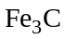) precipitates which is rodlike in shape.
- Between 400-700ºC, the rodlike carbides coalesce to form spherical particles.

(b) The hardness of martensitic plain-carbon steel is decreased by tempering primarily because of the diffusion of carbon atoms; the atoms move from their stressed interstitial lattice sites to form second-phase iron carbide precipitates.

Chapter 9, Problem 58
A 0.65 percent C hypoeutectoid plain-carbon steel is slowly cooled from about 950°C to a temperature just slightly above 723°C. Calculate the weight percent austenite and weight percent proeutectoid ferrite in this steel.

Chapter 9, Solution 58
Error: Reference source not found
The weight percent austenite is calculated from the ratio of the segment of the tie line to the left of the 0.65 percent C to the entire length of the tie line.

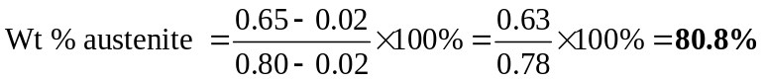

The weight percent proeutectoid ferrite is calculated from the ratio of the segment of the tie line to the right of the 0.65 percent C to the entire length of the tie line.

Chapter 9, Problem 59
A 0.25 percent C hypoeutectoid plain-carbon steel is slowly cooled from 950°C to a temperature just slightly below 723°C.
(a) Calculate the weight percent proeutectoid ferrite in the steel.
(b) Calculate the weight percent eutectoid ferrite and weight percent eutectoid cementite in the steel.

Chapter 9, Solution 59
- The weight percent proeutectoid ferrite just below 723ºC will be the same as that just above 723ºC. It is therefore calculated based upon a tie line similar to that shown in P9.12.

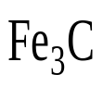
6.67% C
0.25% C
0.02% C
α
α
- The weight percent total cementite and total ferrite are calculated based on the tie line shown to the right.

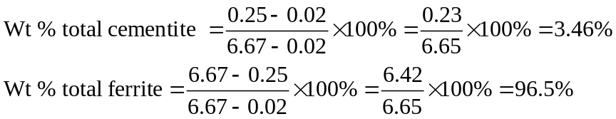

The eutectoid ferrite is equal to the difference between the total ferrite and the proeutectoid ferrite:

Wt % eutectoid ferrite = 96.5% - 70.5% = 26.0%

Since the steel contains less than 0.8 percent carbon, no proeutectoid cementite was formed during cooling. Thus,

Wt % eutectoid cementite = Wt % total cementite = 3.46%

Chapter 9, Problem 60
A plain-carbon steel contains 93 wt % ferrite and 7 wt % Fe₃C. What is its average carbon content in weight percent?

Chapter 9, Solution 60
The average weight percent carbon is calculated based upon the tie line shown below.
6.67% C
x % C
0.02% C
α
α
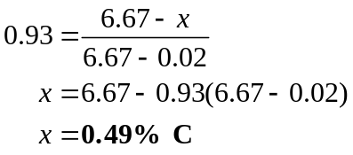

Chapter 9, Problem 61
A plain-carbon steel contains 45 wt % proeutectoid ferrite. What is its average carbon content in weight percent?

Chapter 9, Solution 61
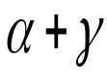
0.80% C
x % C
0.02% C
α
α
γ
γ
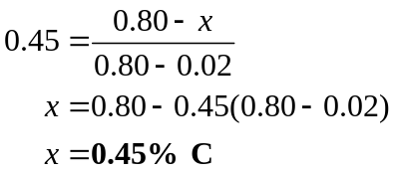

Chapter 9, Problem 62
A plain-carbon steel contains 5.9 wt % hypoeutectoid ferrite. What is its average carbon content?

Chapter 9, Solution 62
The carbon content is related to the eutectoid ferrite by considering the proeutectoid ferrite and the total ferrite present after the eutectoid reaction.

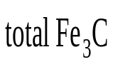
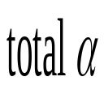
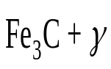
x
Fe₃C
α
α
0.02% C
0.80% C
6.67% C
γ

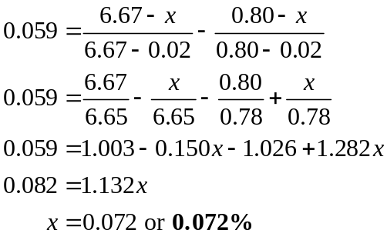

Chapter 9, Problem 63
A 0.90 percent C hypereutectoid plain-carbon steel is slowly cooled from 900°C to a temperature just slightly above 723°C. Calculate the weight percent proeutectoid cementite and weight percent austenite present in the steel.

Chapter 9, Solution 63
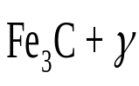
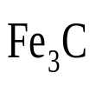
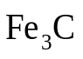
The weight percent proeutectoid cementite and austenite is calculated based on the tie line shown below.
6.67% C
0.90 % C
0.80% C
γ
γ

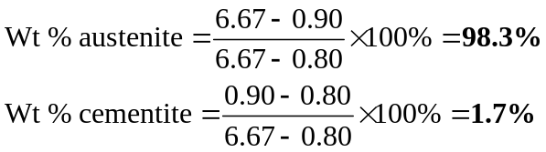

Chapter 9, Problem 64
A 1.10 percent C hypereutectoid plain-carbon steel is slowly cooled from 900°C to a temperature just slightly below 723°C.
(a) Calculate the weight percent proeutectoid cementite present in the steel.
(b) Calculate the weight percent eutectoid cementite and the weight percent eutectoid ferrite present in the steel.

Chapter 9, Solution 64
- The weight percent proeutectoid cementite will be:

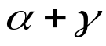
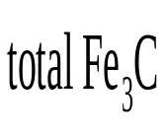
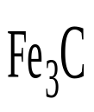
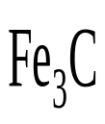
1.10 % C
γ
α
0.02% C
0.80% C
6.67% C
γ
eutectoid α

- As depicted by the tie lines above, the eutectoid reaction will produce:

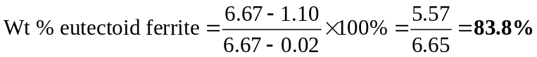

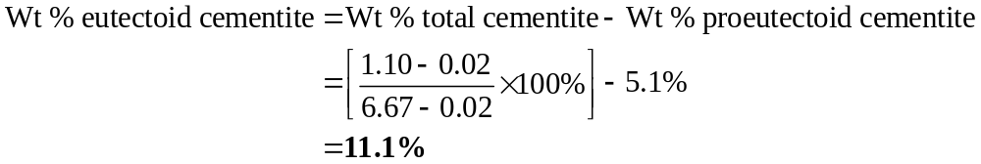

Chapter 9, Problem 65
If a hypereutectoid plain-carbon steel contains 4.7 wt % proeutectoid cementite, what is its average carbon content?

Chapter 9, Solution 65
The average carbon content is:
6.67% C
x % C
0.80% C
γ
γ
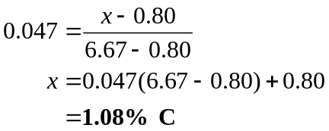

Chapter 9, Problem 66
A hypereutectoid plain carbon steel contains 10.7 wt % eutectoid Fe₃C. What is its average carbon content in weight percent?

Chapter 9, Solution 66
The carbon content is related to the eutectoid cementite by considering the proeutectoid cementite and the total cementite produced by the eutectoid reaction.
x
γ
α
0.02% C
0.80% C
6.67% C
γ

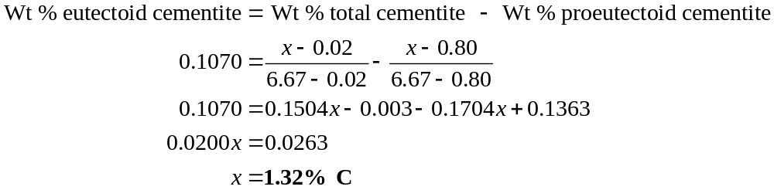

Chapter 9, Problem 67
A plain-carbon steel contains 20.0 wt % proeutectoid ferrite. What is its average carbon content?

Chapter 9, Solution 67
0.80% C
x % C
0.02% C
α
α
γ
γ
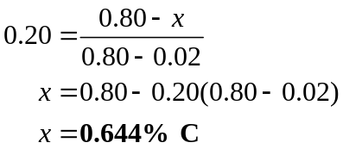

Chapter 9, Problem 68
A 0.55 percent C hypoeutectoid plain-carbon steel is slowly cooled from 950°C to a temperature just slightly below 723°C.
(a) Calculate the weight percent proeutectoid ferrite in the steel.
(b) Calculate the weight percent eutectoid ferrite and eutectoid cementite in the steel.

Chapter 9, Solution 68
0.55 % C
α
α
0.02% C
0.80% C
6.67% C
Fe₃C
γ

- From the tie line, the weight percent proeutectoid ferrite is:

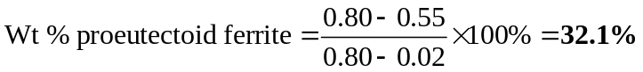
- Below the eutectoid point,

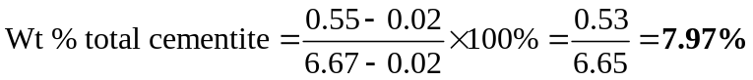
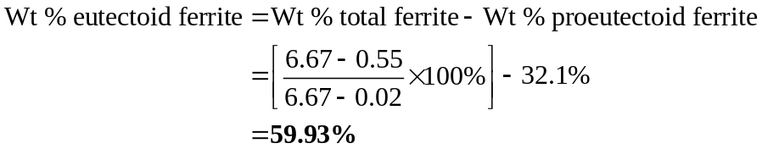

Chapter 9, Problem 69
A hypoeutectoid steel contains 44.0 wt % eutectoid ferrite. What is its average carbon content?

Chapter 9, Solution 69
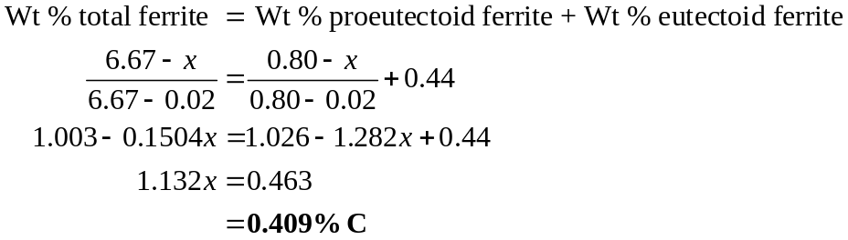

Chapter 9, Problem 70
A hypoeutectoid steel contains 24.0 wt % eutectoid ferrite. What is its average carbon content?

Chapter 9, Solution 70
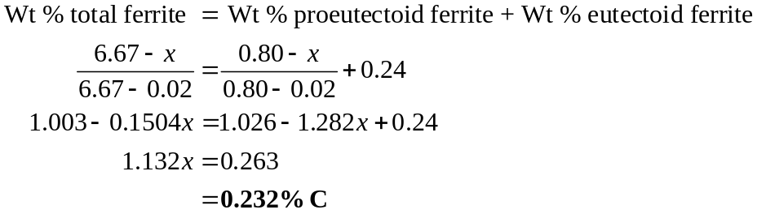

Chapter 9, Problem 71
A 1.10 percent C hypereutectoid plain-carbon steel is slowly cooled from 900°C to a temperature just slightly below 723°C.
(a) Calculate the weight percent proeutectoid cementite present in the steel.
(b) Calculate the weight percent eutectoid cementite and the weight percent eutectoid ferrite present in the steel.

Chapter 9, Solution 71
Error: Reference source not found

- The weight percent proeutectoid cementite will be:

- As depicted by the tie lines above, the eutectoid reaction will produce:

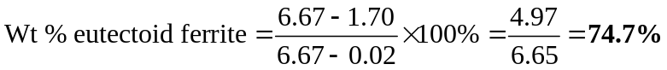

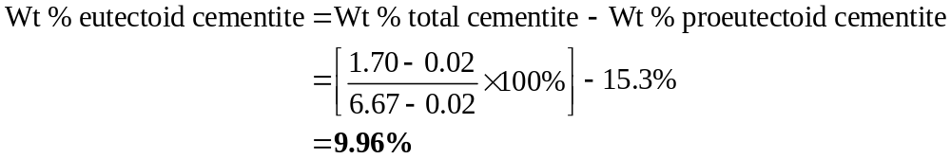

Chapter 9, Problem 72
Draw time-temperature cooling paths for a 1080 steel on an isothermal transformation diagram that will produce the following microstructures. Start with the steels in the austenitic condition at time = 0 and 850°C. (a) 100 percent martensite, (b) 50 percent martensite and 50 percent coarse pearlite, (c) 100 percent fine pearlite, (d) 50 percent martensite and 50 percent upper bainite, (e) 100 percent upper bainite, and (f ) 100 percent lower bainite.

Chapter 9, Solution 72
10⁴
700
600
500
400
300
200
10²
1
10
10³
10⁵
(a)
(b)
(c)
(d)
(e)
(f)
M_{S}
M_{f}

Error: Reference source not found

Chapter 9, Problem 73
Draw time-temperature cooling paths for a 1080 steel on a continuous-cooling transformation diagram that will produce the following microstructures. Start with the steels in the austenitic condition at time = 0 and 850°C. (a) 100 percent martensite, (b) 50 percent fine pearlite and 50 percent martensite, (c) 100 percent coarse pearlite, and
(d) 100 percent fine pearlite.

Chapter 9, Solution 73
Temperature
(c)
(d)
(b)
(a)
Time

Chapter 9, Problem 74
Thin pieces of 0.3 mm thick hot-rolled strips of 1080 steel are heat-treated in the following ways. Use the IT diagram of Fig. 9.23 and other knowledge to determine the microstructure of the steel samples after each heat treatment.
(a) Heat 1 h at 860°C; water-quench.
(b) Heat 1 h at 860°C; water-quench; reheat 1 h at 350°C. What is the name of this heat treatment?
(c) Heat 1 h at 860°C; quench in molten salt bath at 700°C and hold 2 h; water quench.
(d) Heat 1 h at 860°C; quench in molten salt bath at 260°C and hold 1 min; air-cool. What is the name of this heat treatment?
(e) Heat 1 h at 860°C; quench in molten salt bath at 350°C; hold 1 h; air-cool. What is the name of this heat treatment?
( f ) Heat 1 h at 860°C; water-quench; reheat 1 h at 700°C.

Chapter 9, Solution 74
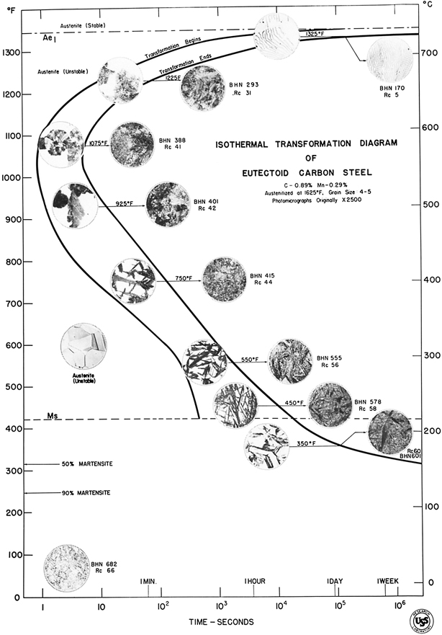

Figure 9.23

- martensite
- tempered martensite, quenching and tempering process
- coarse pearlite
- martensite, marquenching process
- bainite, austempering
- spheroidite

Chapter 9, Problem 75
An austenitized 55 mm diameter steel bar of a 9840 steel is quenched in agitated oil. Predict the Rockwell C hardness at R from (a) the center of the bar, and (b) at the center of the bar.

Chapter 9, Solution 75
(a) For ¾ R from the center of the bar, Fig. 9.40 (ii) indicates that the cooling rate for a 55 mm diameter bar quenched in oil is comparable to the cooling rate at 13 mm from the end of a Jominy bar. Referring to Fig. 9.38, the equivalent Rockwell C hardness for 9840 steel is approximately 52 RC.

(b) For the center of the bar, Fig. 9.40 (ii) indicates an equivalent cooling rate at a position 17 mm from the end of a Jominy bar. Referring to Fig. 9.38, the Rockwell C hardness for 9840 steel associated with this position is approximately 49 RC.

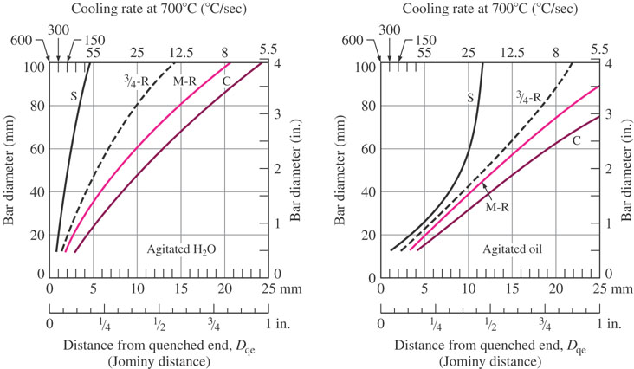

Figure 9.40

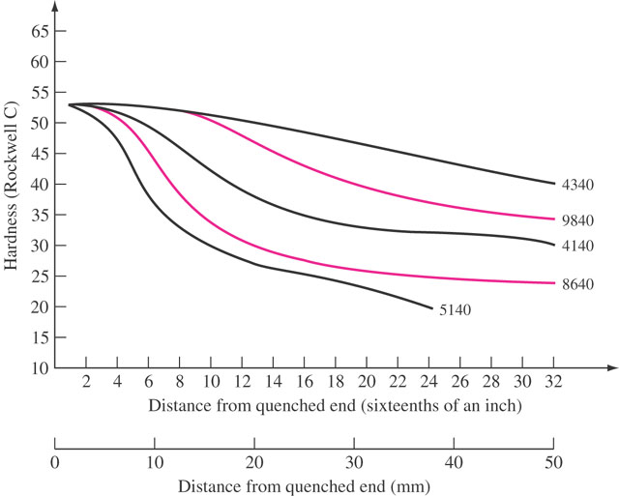

Figure 9.38

Chapter 9, Problem 76
An austenitized 60 mm diameter 4140 long steel bar is quenched in agitated water. Predict the RC hardness at (a) its surface and (b) center.

Chapter 9, Solution 76
(a) For the surface of the bar, Fig. 9.40 (i) indicates an equivalent cooling rate at approximately 2.5 mm from the end of a Jominy bar. Referring to Fig. 9.38, the Rockwell C hardness for 4140 steel associated with this position is about 53 RC.

(b) At the center of the bar, Fig. 9.40 (i) indicates an equivalent cooling rate at a position 13 mm from the end of a Jominy bar. Referring to Fig. 9.38, the Rockwell C hardness for 4140 steel associated with this position is approximately 46 RC.

Figure 9.40

Figure 9.38

Chapter 9, Problem 77
An austenitized 50 mm diameter 5140 steel bar is quenched in agitated oil. Predict what the Rockwell C hardness of the bar will be at (a) its surface and (b) midway between its surface and center (midradius).

Chapter 9, Solution 77
  - For the surface, from Fig. 9.40 (ii) read 9 mm. From Fig. 9.38, read 40 RC.
  - For the midradius, from Fig. 9.40 (ii) read 12.5 mm. From Fig. 9.38, read 34 RC.

Figure 9.40

Figure 9.38

Chapter 9, Problem 78
An austenitized 80 mm diameter 4340 steel bar is quenched in agitated water. Predict what the Rockwell C hardness of the bar will be at (a) its surface and (b) its center.

Chapter 9, Solution 78
  - For the surface, from Fig. 9.40 (i) read 3 mm. From Fig. 9.38, read 53 RC.
  - For the center, from Fig. 9.40 (i) read 18 mm. From Fig. 9.38, read 51 RC.

Figure 9.40

Figure 9.38

Chapter 9, Problem 79
An austenitized 50 mm diameter 5140 steel bar is quenched in agitated oil. Predict what the Rockwell C hardness of the bar will be at (a) ¾ R and (b) the center.

Chapter 9, Solution 79
  - For ¾ R, from Fig. 9.40 (ii) read 11.5 mm. From Fig. 9.38, read 35 RC.
  - For the center, from Fig. 9.40 (ii) read 15 mm. From Fig. 9.38, read 31 RC.

Figure 9.40

Figure 9.38

Chapter 9, Problem 80
An austenitized and quenched 4140 steel bar has a Rockwell C hardness of 40 at a point on its surface. What cooling rate did the bar experience at this point?

Chapter 9, Solution 80
From Fig. 9.38, for 40 RC on the 4140 curve, read 17.5 mm as the distance from the quenched end. From Fig. 9.40(i) or (ii), read a cooling rate of about 10°C/sec.

Figure 9.40

Figure 9.38

Chapter 9, Problem 81
An austenitized and quenched 8640 steel bar has a Rockwell C hardness of 35 at a point on its surface. What cooling rate did the bar experience at this point?

Chapter 9, Solution 81
From Fig. 9.38, for 35 RC on the 8640 curve, read 14.5 mm as the distance from the quenched end. From Fig. 9.40(i) or (ii), read a cooling rate of about 12°C/sec.

Figure 9.40

Figure 9.38

Chapter 9, Problem 82
An austenitized and quenched 5140 steel bar has a Rockwell C hardness of 35 at a point on its surface. What cooling rate did the bar experience at this point?

Chapter 9, Solution 82
From Fig. 9.38, for 35 RC on the 5140 curve, read 11.5 mm as the distance from the quenched end. From Fig. 9.40(i) or (ii), read a cooling rate of about 21°C/sec.

Figure 9.40

Figure 9.38

Chapter 9, Problem 83
An austenitized 40 mm diameter 4340 steel bar is quenched in agitated water. Plot the Rockwell C hardness of the bar versus distance from one surface of the bar to the other across the diameter of the bar at the following points: surface, ¾ R, ½ R (midradius), and center. This type of plot is called a hardness profile across the diameter of the bar. Assume the hardness profile is symmetrical about the center of the bar.

Chapter 9, Solution 83

 | Distance  from  Fig. 9.40(i) | Hardness  from  Fig. 9.38
S | 1.75 mm | 53.0 RC
¾ R | 4.0 mm | 53.0 RC
½ R | 5.75 mm | 52.5 RC
C | 7.5 mm | 52.5 RC
½ R | 5.75 mm | 52.5 RC
¾ R | 4.0 mm | 53.0 RC
S | 1.75 mm | 53.0 RC

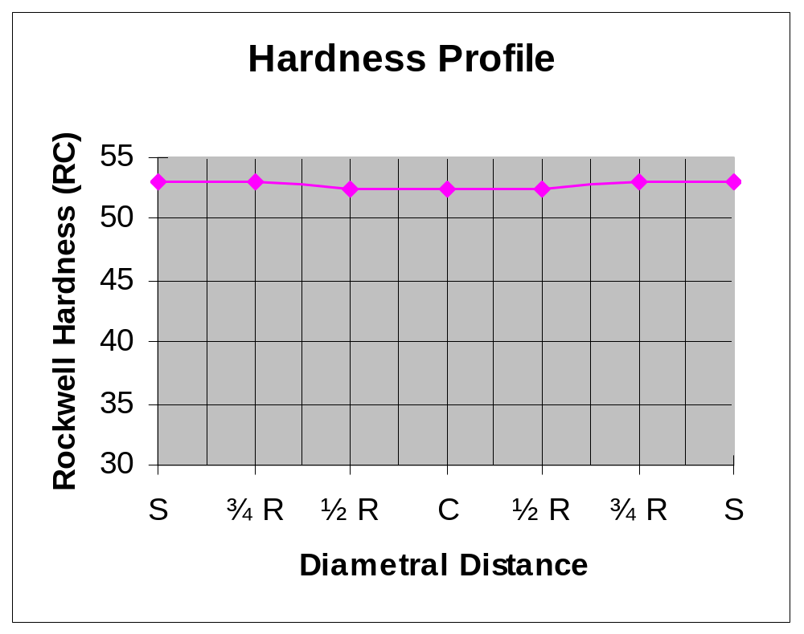

Chapter 9, Problem 84
An austenitized 50 mm diameter bar of 9840 steel is quenched in agitated oil. Repeat the hardness profile of Prob. 9.75 for this steel.

Chapter 9, Solution 84

 | Distance  from  Fig. 9.40(ii) | Hardness  from  Fig. 9.38
S | 9.5 mm | 52.5 RC
¾ R | 11.75 mm | 52.0 RC
½ R | 12.75 mm | 51.0 RC
C | 15.5 mm | 50.5 RC
½ R | 12.75 mm | 51.0 RC
¾ R | 11.75 mm | 52.0 RC
S | 9.5 mm | 52.5 RC

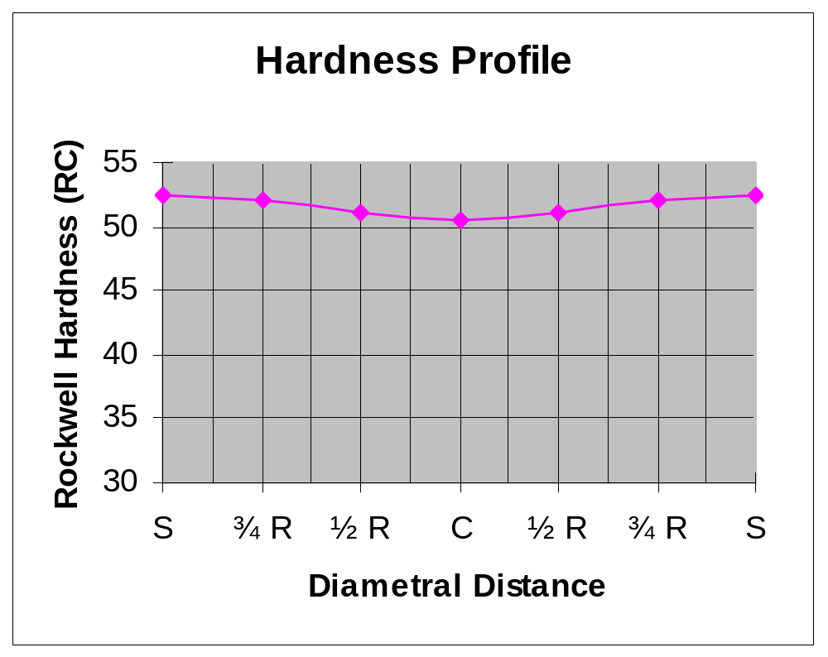

Chapter 9, Problem 85
An austenitized 60 mm diameter 8640 steel bar is quenched in agitated oil. Repeat the hardness profile of Prob. 9.75 for this steel.

Chapter 9, Solution 85

 | Distance  from  Fig. 9.40(ii) | Hardness  from  Fig. 9.38
S | 10.0 mm | 43.0 RC
¾ R | 14.0 mm | 36.0 RC
½ R | 15.5 mm | 33.0 RC
C | 18.75 mm | 31.0 RC
½ R | 15.5 mm | 33.0 RC
¾ R | 14.0 mm | 36.0 RC
S | 10.0 mm | 43.0 RC

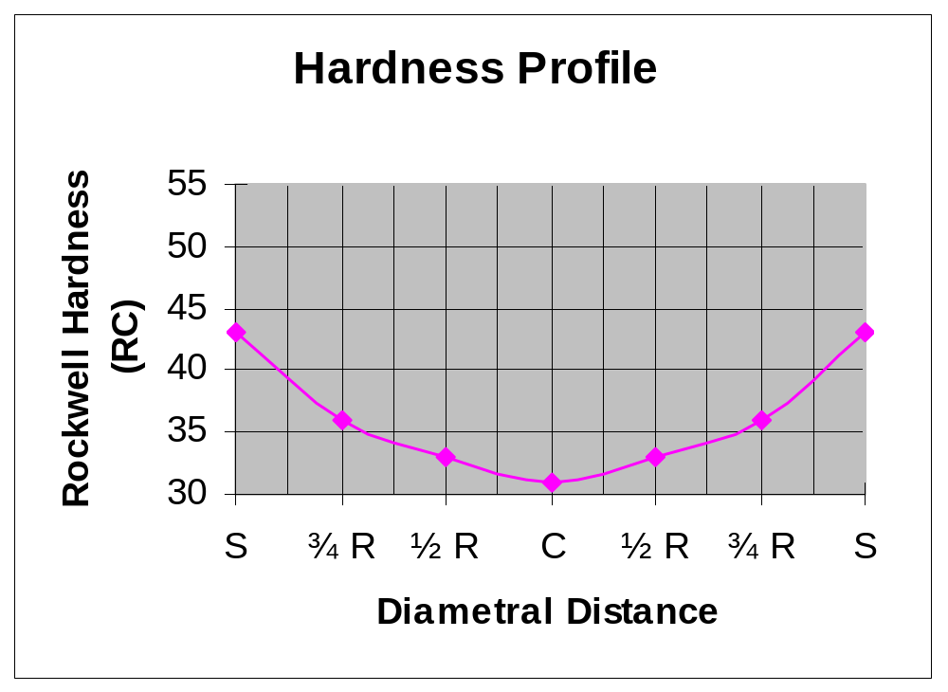

Chapter 9, Problem 86
An austenitized 60 mm diameter 8640 steel bar is quenched in agitated water. Repeat the hardness profile of Prob. 9.75 for this steel.

Chapter 9, Solution 86

 | Distance  from  Fig. 9.40(i) | Hardness  from  Fig. 9.38
S | 2.5 mm | 53.0 RC
¾ R | 7.0 mm | 50.0 RC
½ R | 9.5 mm | 45.0 RC
C | 13.0 mm | 38.0 RC
½ R | 9.5 mm | 45.0 RC
¾ R | 7.0 mm | 50.0 RC
S | 2.5 mm | 53.0 RC

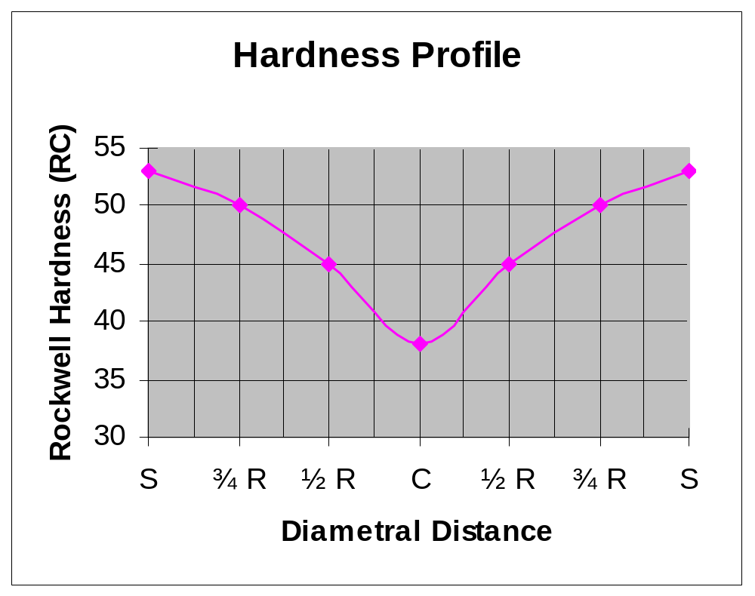

Chapter 9, Problem 87
An austenitized 4340 standard steel bar is cooled at a rate of 5°C/s (51-mm from the quenched end of a Jominy bar). What will be the constituents in the microstructure of the bar at 200°C? See Fig. 9.39.

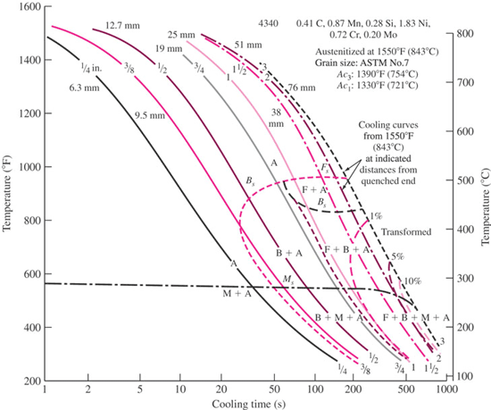

Figure 9.39

Chapter 9, Solution 87

Figure 9.39

The constituents of the microstructure will be ferrite, bainite, martensite and austenite.

Chapter 9, Problem 88
An austenitized 4340 standard steel bar is cooled at a rate of 8°C/s (19.0-mm from the quenched end of a Jominy bar). What will be the constituents in the microstructure of the bar at 200°C? See Fig. 9.39.

Figure 9.39

Chapter 9, Solution 88
An austenitized 4340 standard steel bar is cooled at a rate of 8ºC/s (19.5 mm from the quenched end of a Jominy bar). What will be the constituents in the microstructure of the bar at 200ºC? See Fig. 9.39.

Figure 9.39

The constituents of the microstructure will be bainite, martensite and austenite.

Chapter 9, Problem 89
An austenitized 4340 standard steel bar is cooled at a rate of 50°C/s (9.5-mm from the quenched end of a Jominy bar). What will be the constituents in the microstructure of the bar at 200°C? See Fig. 9.39.

Figure 9.39

Chapter 9, Solution 89

Figure 9.39

The constituents of the microstructure will be martensite and austenite.

Chapter 9, Problem 90
Describe the microstructures of the following Cu-Zn brasses at 75×:
(a) 70% Cu–30% Zn (cartridge brass) in the annealed condition and
(b) 60% Cu–40% Zn (Muntz metal) in the hot-rolled condition.

Chapter 9, Solution 90
- The microstructure of 70% Cu-30% Zn in the annealed condition consists of an alpha solid solution.
- The microstructure of hot-rolled 60% Cu-40% Zn brass consists of two phases – alpha and beta.

Chapter 9, Problem 91
Calculate the wt % θ in an Al–5.0% Cu alloy that is slowly cooled from 548°C to 27°C. Assume the solid solubility of Cu in Al at 27°C is 0.02 wt % and that the θ phase contains 54.0 wt % Cu.

Chapter 9, Solution 91
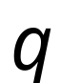
54.0% Cu
α
5.0% Cu
0.02% Cu
α
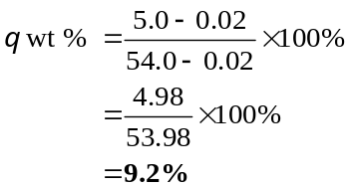

Chapter 9, Problem 92
A binary Al–8.5 wt % Cu alloy is slowly cooled from 700°C to just below 548°C (the eutectic temperature).
(a) Calculate the wt % proeutectic α present just above 548°C.
(b) Calculate the wt % eutectic α present just below 548°C.
(c) Calculate the wt % θ phase present just below 548°C.

Chapter 9, Solution 92

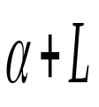
33.2% Cu
8.5% Cu
5.65% Cu
α
α
L
L
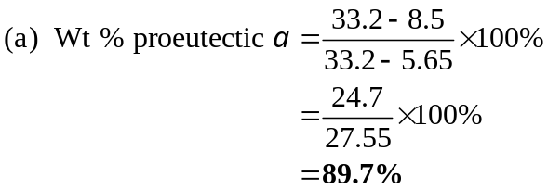
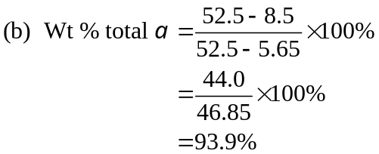
52.5% Cu
α
8.5% Cu
5.65% Cu
α

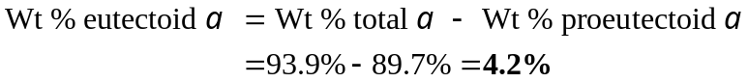

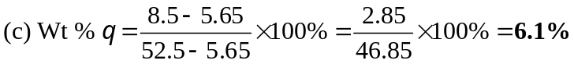

Chapter 9, Problem 93
(a) For a plain carbon steel with 1 wt % carbon content at 900°C, on average, how many carbon atoms can you find in 100 unit cells? (b) If this alloy is cooled to just below 723°C, on average, how many carbon atoms can you find in 100 unit cells in the ferrite phase, a? (c) If at room temperature, the carbon content of ferrite drops to 0.005 wt %, on average, how many unit cells would you have to search to find one carbon atom? Can you explain the differences in the three answers?

Chapter 9, Solution 93
- At 900°C, the phase structure is austenitic (FCC). Assume 100 of alloy (99gFe + 1gC).
Number of carbon atoms: 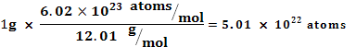
Number of Fe atoms: 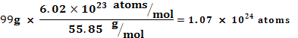
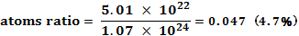
Approximately 5 atoms of C for every 95 atoms of Fe
FCC (γ): 100 unit cells have 400 Fe atoms. This results in 19C atoms (4.7%).

- Below 723°C, the phase structure is a mixture of ferrite (α) and cementite (Fe₃C). According to figure 9.6, the carbon content of α is 0.02 wt%.
Number of carbon atoms: 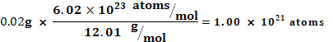
Number of Fe atoms: 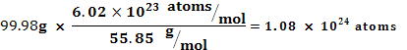
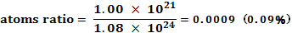
BCC (α): 100 unit cells have 200 atoms. This results in 0.18 carbon atoms in 100 unit cells (0.09%). ( one carbon atom in 500 cells).

- At room temperature, the carbon content drops to 0.005 wt%.
Number of carbon atoms:
Number of Fe atoms:
BCC (α): 100 unit cells have 200 atoms. This results in 0.046 carbon atoms in 100 unit cells. ( one carbon atom in 2000 unit cells).

- FCC γ has a much higher solubility for carbon than BCC α because of the larger interstitial spaces available.
BCC α can support more C atoms at elevated temperatures due to higher energy of the C atoms and higher vibrational amplitude of the C atoms and higher vibrational amplitude of Fe atoms.

Chapter 9, Problem 94
In Fig. 9.19, consider a plain carbon steel with carbon 1.2 wt % carbon. At this carbon content, find, using the figure, the hardness of martensitic steel, pearlitic steel, and spheroidized steels. What is the reason for the drastic difference in hardness when they all have the same composition? Explain in detail.

Chapter 9, Solution 94
The hardness values for 1.2 wt% C steel in the spheroidized, pearlitic and martensitic conditions are 9 HRC, 27HRC and 65-68 HRC respectively. Clearly, martensitic structure results in the hardest steel followed by pearlitic and spheroidized steels.
To understand the reason for differences in hardness compare the microstructure of spheroidite (figure 9.31), pearlite (figure 9.12) and martensite (figure 9.14). Dislocations can move more freely in spheroidite, thus this alloy is the softest.
Martensite has the most randomly oriented microconstituents and resists movement of dislocations, thus the hardest metal. Pearlite resists dislocation movement less than martensite but more than spheroidite.

Chapter 9, Problem 95
For eutectoid steel, Fig. 9.24, the upper bainite microstructure (produced at isothermal transformation temperature of 350°C to 550°C) has larger Fe3C regions than lower bainite (produced at isothermal transformation temperature of 250°C to 350°C). Can you explain why?

Chapter 9, Solution 95
This is a direct result of higher diffusion rates of carbon at higher temperatures. Because the diffusion rate of carbon is higher in the upper bainite region, cementite regions will grow larger.

Chapter 9, Problem 96
According to Fig. 9.25, it is impossible to form 100% martensitic steel from a hypoeutectoid steel (0.47 wt % carbon). Explain why.

Chapter 9, Solution 96
Examination of figure 9.25 shows that no matter how rapidly one cools the hypoeutectoid steel, the cooling path passes through a region in which ferrite and cementite will be produced. Compare figure 9.25 with that in figure 9.23 and you will notice that the “S” curve in figure 9.25 has shifted to the left. This indicates that even under rapid cooling, some portion of the austenite transforms to ferrite and cementite.

Chapter 9, Problem 97
How would the schematic of the Isothermal Transformation Diagram for a plain carbon steel of 1.1 wt % carbon be generally different than that of a eutectoid steel depicted in Fig. 9.23? Show the differences schematically.

Chapter 9, Solution 97
Figure 9.23 shows that the S-shaped curve representing the beginning of the isothermal transformation of austenite starts at 723°C for eutectoid steel.
For hypereutectoid steel, the starting curve will originate just under 900°C representing the formation of proeutectoid cementite.

723°C
eutectoid
723°C
900°C
hypereutectoid
Fe₃ C + γ

Conversely, for a hypoeutectoid steel, the starting curve will start above 723°C representing the formation of proeutectoid α.
723°C
hypoeutectoid
800°C
Proeutectoid α
α+ γ

Chapter 9, Problem 98
The microstructure of a cast plain carbon steel (0.4 wt % carbon) component is observed to be too coarse, nonhomogenous, and soft. How would you refine the grain structure of the component without significantly decreasing its ductility?

Chapter 9, Solution 98
We can achieve grain refinement without significant loss in ductility by heating the component to the austenitic region and then air cooling it in still air. This process is called normalizing.

Chapter 9, Problem 99
As the tempering temperature of martensitic plain carbon steels increases, the hardness gradually decreases (see Fig. 9.32). Explain why from an atomic scale point of view.

Chapter 9, Solution 99
As martensite is formed, carbon atoms become trapped with iron atomic structure (BCT). As martensite is tempered, many of the trapped carbon atoms leave the iron lattice and form the second phase (Fe₃C). This will soften the martensite. As tempering temperature increases, a larger portion of these carbon atoms leave the BCT structure to form Fe₃C and thus the metal becomes softer.

Chapter 9, Problem 100
In Fig. 9.33, if the cooling curve for the center of the specimen, only, is shifted to the right, from its current position, so it intersects a small section of the S curve, how will the microstructure within the specimen change?

Chapter 9, Solution 100
If the cooling curve for the center of the specimen is shifted to the right, intersecting the S curve, some of the austenite on the centerline of the specimen will transform to pearlite. Because the surface cooling curve has not shifted, the surface will transform completely to martensite.

Chapter 9, Problem 101
Alloy steel 4340 is highly hardenable because the decomposition of austenite to ferrite and bainite is delayed. Explain, in terms of the cooling curve, how this affects hardenability. Use Fig. 9.39 to answer the question.

Chapter 9, Solution 101
If it takes longer for austenite to decompose into ferrite and bainite, this means that the S curve shifts to the right. (see below)
S-curve for plain carbon eutectoid steel
Cooling rate to form martensite for 4340 alloy
S-curve for 4340
Cooling rate to form martensite for plain carbon steel
B+A
F+B+A

This allows for lower cooling rates to form martensite in 4340. Compare the slopes of the two dotted lines.

Chapter 9, Problem 102
Estimate the cooling rate between 400°C and 600°C at (a) a distance of 6.3 mm from the quenched end, (b) 19 mm from the quenched end, and (c) 51 mm from the quenched end. What does the comparison of these rates tell you about the outcome?

Chapter 9, Solution 102
Cooling rates:
@ 6.3 mm → 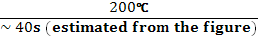 = 50°C/s
@ 19 mm → 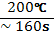 = 1.25°C/s
@ 51 mm → 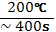 = 0.5°C/s
The different rates of cooling at different depths (refer to figure 9.39) show that there will be different mixtures or ratios of microstructures within the same component.
For instance, according to figure 9.39, at 6.3mm with a cooling rate of 50°C/s, the microstructure will be M + A; at 19mm, the microstructure will be B + M +A; and at 51mm with a cooling rate of 0.5°C/s, the microstructure will consist of F + B + M +A.

Chapter 9, Problem 103
Refer to Table 9.12 and compare the compositions of austenitic stainless, ferritic, and martensitic stainless steels. (a) Can you explain why austenitic stainless steel is more resistant to corrosion than ferritic and martensitic? (b) Why can martensitic stainless steel be heat treated to higher strengths than ferritic and austenitic?

Chapter 9, Problem 103
Ferrite stainless steel: 17-25 wt% Cr 0.012 - 0.20 wt% C
Martensitic stainless steel: 12-17 wt% Cr 0.15 – 1.1 wt% C
Austenitic stainless steel: 17-19 wt% Cr 7 – 10 wt% Ni, small amounts of Ti & C.
- Comparison shows that ferritic and austenitic steels have limited or no amount of C in them.
- In all stainless steels, the main ingredient is 12-25 wt% Cr. Ni is the element that causes the FCC structure to be retained in austenitic stainless steel.
- (a) Austenitic steel is more resistant to corrosion because it does not contain significant amounts of carbon. We will discuss this in more detail in chapter 13.
(b) Martensitic steel can be heat treated to higher strengths than the other stainless steels because it contains significant wt % of carbon. It can form martensitic microstructure.

Chapter 9, Problem 104
Both 4140 and 4340 steel alloys may be tempered to achieve tensile strengths above 200 Ksi. Which one would you use for manufacturing of an aircraft landing gear? Which one would you use for manufacturing of heavy-duty gears? Explain your answer.

Chapter 9, Solution 104
Compositions:
4140 : 0.4C, 1.0Cr, 0.9Mn, 0.2Mo
4340 : 0.4C, 0.8Cr, 0.9Mn, 0.2Mo, 1.83Ni

Note that both metals have similar amounts of C, Cr, Mn and Mo. The only difference is that 4340 contains 1.83 wt% of Ni and 4140 does not contain any Ni.
Nickel helps to improve the hardenability of 4340. Thus, the strengthening mechanism through quenching can occur at lower cooling rates. This will also lead to a more uniform strengthening of the component.
Heavy duty gears require a combination of toughness (interior) and hardness (surface).
Aircraft landing gears need uniform strengthening throughout.
Thus, 4340, due to its better hardenability would be a better choice for landing gears.

Chapter 9, Problem 105
Ductile cast iron (Q & T) and aluminum alloy 7075 (T-6) can both be applied in automotive suspension components. What would be the advantage of using each metal in producing the part?

Chapter 9, Solution 105
Automobile suspension components must be made from materials that are strong, tough and fatigue resistant. The material must also have good casting characteristics since suspension components are mostly produced using casting.
Ductile cast iron is strong (120 ksi UTS), tough, hardenable and with some ductility ( 2%). However, its high density and limited ductility could pose a disadvantage for this application. Complex parts can easily be made from this metal using the casting process.
Aluminum alloy 7075 T6 is also strong (73 ksi) but not as strong as cast iron (Q & T). It has better ductility ( 8%) and excellent fatigue characteristics. It is also lighter (lower density) than cast iron.

Chapter 9, Problem 106
Aircraft fuselage is made of aluminum alloys 2024 (T6) or 7075 (T6). What are the advantages of using these alloys over other metal alloys? What factors must you consider in this selection?

Chapter 9, Solution 106
Both of these aluminum alloys are heat treatable to high strengths (2024 – 64 ksi UTS; 7075 – 73 ksi UTS). Both have excellent fatigue resistance properties which is crucial for aircraft structure applications. The alloys (Al alloys) are light weight which is another crucial characteristic. It is very easy to manufacture sheets of various thicknesses from these alloys using the rolling process. The only disadvantage is that these alloys are susceptible to corrosion in an environment that salt (NaCl) is present. Thus, regular checks for corrosion must be made.

Chapter 9, Problem 107
What are the highest-strength commercial copper alloys? What type of heat treatment and fabrication method makes these alloys so strong?

Chapter 9, Solution 107
Three examples of high strength Cu alloys are:
C17000 : 99.5Cu, 1.7Be, 0.2Co
Strengthened to 180 ksi through solution heat treating

C82400 : 96.4Cu, 1.7Be, 0.25Co
Strengthened to 150 ksi through heat treatment

C61400 : 95Cu, 7Al, 2Fe
Strengthened to 89 ksi through cold working

Chapter 9, Problem 108
Why doesn’t the equilibrium precipitate directly from the supersaturated solid solution of a precipitation-hardenable alloy if the aging temperature is low? How can the equilibrium precipitate be formed from the supersaturated solid solution?
Chapter 9, Solution 108
At lower temperatures (for aging), only small amounts of activation energy is available. Under these conditions, spontaneous decomposition of the supersaturated solid solution does not occur. Instead, precipitation zones will form. Higher aging temps are required to produce the equilibrium precipitate.

Chapter 9, Problem 109
What makes it possible for an austenitic stainless steel to have an austenitic structure at room temperature?

Chapter 9, Solution 109
Presence of about 7-20 wt% nickel, an FCC metal, will help preserve the FCC structure of γ iron at room temperature.

Chapter 9, Problem 110
(a) What makes austenitic stainless steels that are cooled slowly through the 870°C to 600°C range become susceptible to intergranular corrosion? (b) How can the intergranular susceptibility of slow-cooled austenitic stainless steels be prevented?

Chapter 9, Solution 110
If the cooling rate is slow through the 870°C to 600°C range, chromium carbides form and precipitate at the grain boundary. As a result, the protective effect of chromium at the grain boundary will be diminished (since chromium is locked in the carbides) and will be susceptible to corrosion. This is one reason that austenitic steel contains very little carbon. (< 0.03 wt%).
- Adding alloying elements that form carbides more readily than chromium (for instance niobium).

Chapter 9, Problem 111
Consider the intermetallic compound NiAl. What can you say about the nature of bonding between Ni and Al? How do you support your answer?

Chapter 9, Solution 111
- NiAl is an intermetallic alloy (refer to figure P8.38 for the appropriate phase diagram). Notice in the figure that the intermetallic is not represented by a vertical line (is not stoichiometric) and rather in a large region around 64 wt% to 76 wt% Ni. This indicates that some substitution between Ni and Al takes place.
We expect that the bonding between Al and Ni to be a mix of metallic and covalent.
- Referring to the electronegativity values for Al and Ni, figure 2.14, we notice that they are very close: 1.5 and 1.8 respectively. This supports the fact that covalent bonding will also take place.

Chapter 9, Problem 112
Plain carbon and alloy steels are extensively used in the manufacturing of bolts and
screws. Give as many reasons as you can for this.

Chapter 9, Solution 112
Bolts and screws must be made of materials that are high strength (to avoid failure); high modulus of elasticity (to allow high pre-loads without yielding); resist fatigue failure (especially in applications that involve loading and unloading) even in the presence of threads; be economical; have ease of manufacturing. Steels satisfy all of these conditions. To avoid corrosion, protective coating can be applied.

Chapter 9, Problem 113
To avoid surface pitting of heavy duty mating gears (due to high pressure contact and fatigue), which of these metals would you select in the manufacturing of the gear: 4140 steel or cast iron? Why?

Chapter 9, Solution 113
Both metals in the quenched and tempered state can be used for heavy duty gears. The gears must have very high surface and subsurface hardness to protect against pitting and fracture.
For this purpose 4140 (Q & T) with a yield strength of 208 ksi and tensile strength of 225 ksi is preferable over ductile cast iron (Q & T) with a yield strength of 90 ksi and tensile strength of 120 ksi.
Note that the stresses between mating gears could reach very high levels and additional surface hardening treatments may be needed.

Chapter 9, Problem 114
(a) Give examples of components or products that were originally made from steel alloys and are now made from aluminum alloys. (b) In each case give reasons as to why this change took place.

Chapter 9, Solution 114
Automobile wheels: to save weight (steel to aluminum)
Automobile body: to save weight and improve aesthetics (steel to aluminum)
Engine block: to save weight, protect against corrosion (cast iron to aluminum)
Bicycles: to save weight and protect against corrosion (steel to aluminum)
Automotive pistons: to save weight and protect against corrosion (steel to aluminum)
Heat exchangers: to protect against corrosion

The major disadvantage with aluminum alloys compared to steel is poor weldability. Aluminum’s poor weldability is due to high thermal conductivity and low melting temperature.

Chapter 9, Problem 115
You are given a small steel component identified only as plain carbon steel and you are told to increase its hardness to 60 HRC. However, no amount of heat treatment (quenching) achieves this. What is your conclusion?

Chapter 9, Solution 115
According to figure 9.19, the plain carbon steel must be of hypoeutectoid variety with carbon content less than 0.4 wt%.

Chapter 9, Problem 116
Design a heat treatment process based on the Isothermal Transformation Diagram of eutectoid carbon steel that would result in a metal with (a) Rockwell hardness greater than 66 HRC, (b) Rockwell hardness of approximately 44 HRC, and (c) Rockwell hardness of 5 HRC. Use Fig. 9.23.
Chapter 9, Solution 116
- HRC 66: Quench the component at a very rapid rate (cool from 900°C to 100°C in less than one second). This will achieve a fully martensitic microstructure with a hardness of 66 Rc.
- HRC 44: Quench to 400°C and maintain for 300 to 400 seconds. Cool to room temperature. Results in a bainitic structure.
- HRC 5: Quench to 700°C and maintain for about an hour. Cool to room temperature. Results in a coarse pearlite microstructure.

Chapter 9, Problem 117
A machinist threads a cylinder from annealed 1080 steel and makes sure that the threads match that of a nut. He then heat-treats the threaded cylinder by austenitizing, quenching, and tempering to achieve a higher hardness. (a) After the heat treatment process, the threads no longer fit those of the nut. Explain why? (b) How would you avoid this problem?
Chapter 9, Solution 117
- The quenching process is an energetic process with severe thermal changes to the component. This will change the dimensional tolerances of the component. Even small local changes in dimension will result in a lack of mating between threads.
- The best approach would be to heat-treat the cylinder to appropriate hardness and then thread it. You would need a very hard tool to achieve this but it can be done.

